

Edinburgh College Research Plan

2023-28

Corporate Development

**EXECUTIVE SUMMARY**

The new Edinburgh College Strategic Plan identifies research and innovation activity as a critical success factor to the delivery of ambitions identified in the framework. In addition, a number of national and regional policy objectives also place importance on enhancing the breadth, quality and impact of research activity across Scotland, and the rest of the UK.

This research plan has been developed in response to the above strategic ambitions, and identifies three tactical aims, to improve the breadth, quality and impact of research activity at Edinburgh College. These aims are aligned to the three strategic themes in the Edinburgh College Strategic Framework:

1. People - To produce high quality research activity to in order to develop our staff, deliver an excellent student experience, and improve the quality of learning, teaching and assessment.
2. Place - To increase the scale and quality of research activity with communities, public and third sector partners, universities, industry and employers, in order to aid inclusive and sustainable economic growth.
3. Performance - To improve the resourcing, coordination, governance and reporting of research activity to demonstrate progress and positive impact.

In order to deliver these aims, and related objectives indicated in the main plan, the College has established an Edinburgh College Research Unit.

The Unit brings together staff, students and partners, including the Edinburgh College Development Trust, through a range of groups and activities. These include, sourcing research resources, funding research scholarships, organizing research placements, developing a staff and student research forum, identifying opportunities for research projects with business, universities, colleges, and other public and third sector partners.

All of this activity is overseen, coordinated and governed by the Edinburgh College Research Committee. This Committee reports to the Executive and Senior Management Teams, and thereafter to the College’s Corporate Development Committee, on all elements of activity to ensure good governance and public reporting.

The Research Committee also identifies how research activity will be funded and managed, how staff and students will be involved, what governance and ethical considerations and arrangements are in place, and how research will be published and utilised to ensure positive and lasting impact.

For further information about this framework, and the Edinburgh College Research Unit, and the Research Committee, please contact [michael.jeffrey@edinburghcollege.ac.uk](mailto:michael.jeffrey@edinburghcollege.ac.uk) – Vice Principal Corporate Development Or [nick.croft@edinburghcollege.ac.uk](mailto:nick.croft@edinburghcollege.ac.uk) – Director of Communications, Policy and Research.

**BACKGROUND AND CONTEXT - Where are we now?**

Edinburgh College and its legacy colleges have a history of engaging and participating in research activity, which demonstrates organisational research capacity and a commitment to good research practice. Examples of such research activity include:

- Socio economic impact of colleges

- CDN colleges tackling poverty report

- CDN schools college partnership report

- Solar PV Meadow research report

- Innovation capacity and need in local businesses research report

- Addressing fear and anxiety in college leaners

- How to best prepare college learners pre-entry to college

- Integrating creative thinking into college courses

- History of Edinburgh College

- Student travel patterns pre and post Covid 19 Pandemic

The recently approved Edinburgh College Strategic Framework places more emphasis on the need for the College to support, fund and engage in more research activity. It regards such activity as a critical success factor in order to improve student outcomes, stimulate business innovation, and to enable a socially and environmentally just society and economy.

A recent review by the SFC into knowledge exchange and information also sought to encourage the college sector to engage more in research and innovation activity, with the above objectives in mind. Review recommendations have led to the introduction of new research funding streams for colleges and the identification of the need for more funding of joint research between colleges and universities.

Scottish Government policy on economic transformation, tackling poverty and addressing the climate crisis also require colleges to be more active in the research space. The UK Government and the UKRI have also indicated the need for more research and innovation activity to take place across the UK, in order to stimulate economic growth, tackle climate change, and deliver the ’Levelling Up’ agenda.

The Edinburgh and South East Scotland City Region Deal also provides for a major opportunity of investment activity into college-based data driven innovation and research. Specifically, partnership activity with the four local universities, five local authorities and four neighboring regional colleges involved in delivery.

Given all of the above, Edinburgh College has now, following discussion amongst staff, students and key stakeholders, produced this new Research Plan 2023. It sets out high level aims and more detailed operational objectives that more clearly articulate the College’s ambition to enhance its research capacity and methodologies, including approaches to action research, and deliver research activity that has meaningful and sustainable impact.

Edinburgh College is not the only college in Scotland to aspire to improve approaches to, and the impacts of, college sector research activity. In recognition of this, the Colleges Development Network in Scotland has now set up a Research and Enhancement Centre to assist colleges to move into new research spaces, and new collaborations.

Given all of the above, Edinburgh College has now established a Research Unit and Research Committee to drive forward its research ambitions, and deliver on commitments described in this plan.

A summary of eight key activities of the ECRU, as of March 2023, is summarised below:

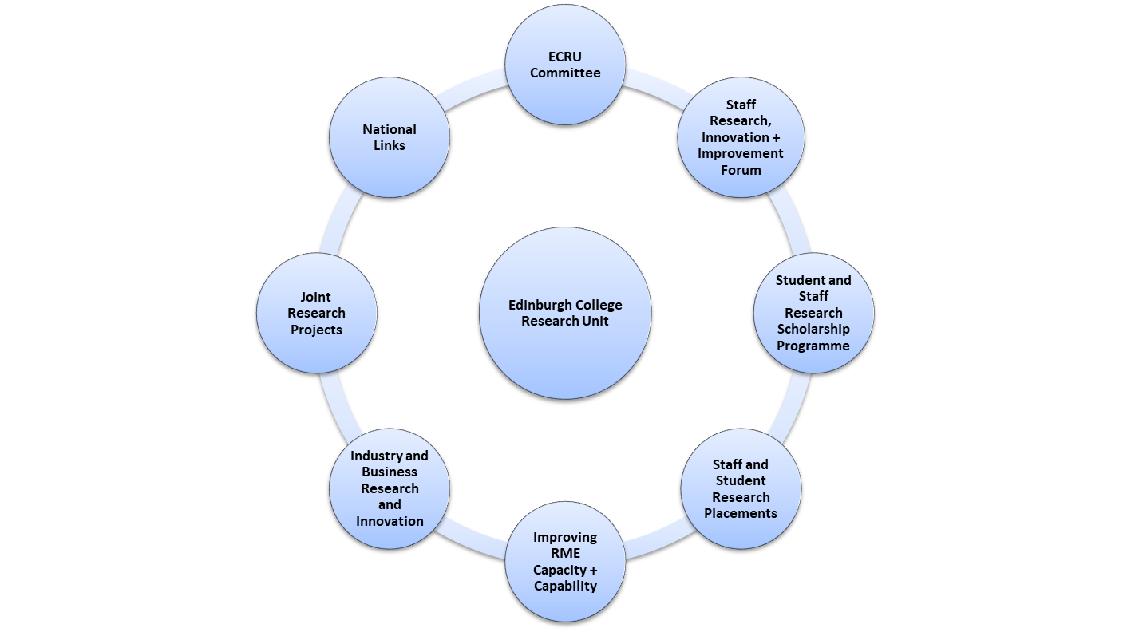

**STRATEGIC AIMS AND OBJECTIVES - Where do we want to get to?**

Edinburgh College Research Unit strategic objectives are:

1. People - To produce high quality research activity to in order to develop our staff, deliver an excellent student experience, and improve the quality of learning, teaching and assessment
2. Place - To increase the scale and quality of research activity with communities, public and third sector partners, universities, industry and employers, in order to aid inclusive and sustainable economic growth
3. Performance - To improve the resourcing, coordination, governance and reporting of research activity to demonstrate progress and positive impact

The table below indicates the aims and objectives of this plan that will drive forward the work of ECRU and the Research Committee, aligned to the above three aims:

|  |  |
| --- | --- |
| **Aims** | **Objectives** |
| People - To produce high quality research activity to in order to develop our staff, deliver an excellent student experience, and improve the quality of learning, teaching and assessment | * Improve the student experience * Improve student outcomes * Enhance student engagement * Improve staff development |
| Place - To increase the scale and quality of research activity with communities, public and third sector partners, universities, industry and employers, in order to aid inclusive and sustainable economic growth | * Provide more research and innovation support to local business * Better contribute to the regional growth framework * Deliver more product design and innovation * Deliver more community planning partnership research activity |
| Performance - To improve the resourcing, coordination, governance and reporting of research activity to demonstrate progress and positive impact | * Improve the mapping and recording of college research activities * Secure more resources for college research activity * Better measure the impact of college research activity |

These aims and objectives are well aligned to the College Development Network Research and Enhancement Centre workplan aims, which are:

1. **College of the Future** - Working with Colleges Scotland to providing insight into the ways in which colleges will need to develop their practice to meet the changing needs of learners, employers, and communities. Providing insight into the processes and practice of college boards to ensure effective and sustainable governance. Supporting colleges to further develop their practice within an evolving tertiary sector and integrated quality framework
2. **Pathways from Poverty -** Highlighting the role colleges are playing in supporting their communities to overcome the complex challenges of poverty through the dissemination of good practice. Working with colleges and partners to help them to share practice and expand and enhance the delivery of activity that supports learners facing the complex challenges of poverty.
3. **Innovation in Learning & Teaching - E**nabling college staff to develop their pedagogy and professional practice to support the delivery of innovative approaches to learning and teaching. Working with partners to support effective planning of new and innovative curricula.
4. **Economic Transformation, Net Zero & Sustainability** - Working with colleges to develop and disseminate best practice in embedding sustainability in the curriculum. Working with colleges to develop their strategic practice in supporting economic renewal at local, regional, and inter-regional levels. Working with sector partners to support the delivery of the Colleges Climate Commitment.

Edinburgh College is committed to working closely with CDN on joint research activity to achieve these respective aims. Specifically, the College will work with CDN on developing and delivering joint research project funding bids, and securing other resources, for research activity.

**PERFORMANCE MANAGEMENT - How do we know we have got there?**

The Edinburgh College Research Committee is responsible for coordinating and reporting all performance management matters relating to research activity at the College.

The Committee has agreed a set of KPIs that will aid performance management of such activity, which are listed below:

* Total amount of internal and external funding secured p.a. for research activity
* Total number of completed research projects p.a.
* Total number of staff and students involved in completed research projects
* Qualitative analysis of research project impacts

These KPIs along with other qualitative and quantitative performance management analysis will be reported by the Research Committee to the Executive and Senior Management Teams, and the Corporate Development Committee.

**GOVERNANCE - Who is responsible?**

The Edinburgh College Research Committee has lead governance responsibility for all college research activity, and it reports to the Executive and Senior Management Teams and Corporate Development Committee.

An important element of this governance oversight is the need to ensure good research ethics are embedded in all Edinburgh College research activity. Three key ethical considerations informing all research will include:

* protecting the rights of research participants
* enhancing research validity
* maintaining scientific integrity

With regard to collecting data from people to inform college research activity, the College will address the following ethical issues:

| **Ethical issue** | **Definition** |
| --- | --- |
| **Voluntary participation** | Our participants are free to opt in or out of the study at any point in time. |
| **Informed consent** | Participants know the purpose, benefits, risks, and funding behind the study before they agree or decline to join. |
| **Anonymity** | We don’t know the identities of the participants. Personally identifiable data is not collected. |
| **Confidentiality** | We know who the participants are but we keep that information hidden from everyone else. We anonymise personally identifiable data so that it can’t be linked to other data by anyone else. |
| **Potential for harm** | Physical, social, psychological and all other types of harm are kept to an absolute minimum. |
| **Results communication** | We ensure our work is free of plagiarism or research misconduct, and we accurately represent our results. |

The Research Committee is also responsible for ensuring consistent use of language and terminology relating to research activity to ensure consistency of approach and methodology across the College. Key terms and concepts with regard to this matter are indicated at Appendix 1 below.

**PERFORMANCE REPORTING - When will we review and report progress?**

Progress will be reviewed on a quarterly basis by the Research Committee, and reported to the Corporate Development Committee four times a year.

In turn, the Corporate Development Committee will report to the Board of Management on an annual basis through its annual report to the Board of Management.

This plan will be reviewed in 2027 with a view to developing a new plan by 2028.

**CONTACT DETAILS - Who do I contact to get more information or other copies?**

For further information about this framework, and the Edinburgh College Research Unit, and the Research Committee, please contact:

[michael.jeffrey@edinburghcollege.ac.uk](mailto:michael.jeffrey@edinburghcollege.ac.uk) – Vice Principal Corporate Development

Or

[nick.croft@edinburghcollege.ac.uk](mailto:nick.croft@edinburghcollege.ac.uk) – Director of Communications, Policy and Research

**Appendix 1 Key Research Definitions, Activities and Outputs**

**Research culture** may be seen as a collection of values, expectations, organisational structures, policies and everyday practices that facilitate the pursuit of research and scholarship as a collective commitment by an institution and key to stated goals.

**Researchers** are defined as people with specialist knowledge about theories, methods and information concerning their field of enquiry. They actively explore, interpret and share advances in knowledge, allowing others to develop new insights and understandings of the physical, biological and social contexts in which we live. Significantly, researchers belong to a dynamic and evolving community that builds and sustain both disciplinary and cross-disciplinary networks that create and nurture knowledge exchange and scholarly activity.

**Research activities** can be characterised as original independent investigation (including fieldwork trials) undertaken to advancing knowledge and understanding. Research is a developmental, creative, cumulative enterprise conducted by people with specialist knowledge about theories, methods and information concerning their field of enquiry. Research involves inquiry of an experimental or critical nature driven by a research question, hypothesis or intellectual position capable of rigorous scrutiny and assessment by experts in a given field/dripline.

**Research activities** operate from paradigms that represent different understandings of and assumptions about the nature of research and associated modes of investigation and the creation of knowledge. Therefore, in certain areas and disciplines research activities may be embodied in the form of artistic works, cultural artefacts, performances or designs that lead to new or improved insights and innovations. This may be achieved through various forms of dissemination including, but not limited to, publication, manufacture, construction, public presentation/performance, or physical artefacts for display.

**Research output** is defined here as a particular publication, innovation/design, presentation, communication or pathway by which research is made available to the wider community. It includes research outputs of direct relevance to specific areas and groups including: communities, government, industry and commerce. To ensure legitimacy, the research output is authenticated and endorsed through peer review process.

**Research impact** is the verifiable contribution the research output makes to society and the economy. Societal impact includes infrastructure and policy that supports a nation to meet its social needs and improved quality of life, such as health and education systems. It also relates to public and policy debate and aspects that enhance understanding of social and ethical values which contribute to a civilised, democratic and secure society. Research can also have cultural impact, seen here as stimulating creativity and cultural production, as well as understanding and preserving cultural heritage. Naturally, research impact can have a global impact.

**Knowledge exchange** is a term used to encompass a very broad range of activities to support mutually beneficial collaborations between universities, businesses and the public sector. It is an ‘interactive activity’ where people meet to share and exchange ideas. Sometimes knowledge exchange activities identify new opportunities relating to research and innovation. Developing new insights and delivering external impact is a key dynamic here.

**Scholarship** is broadly defined as an activity that updates the knowledge of an individual or adds to their existing skill and experience. The knowledge already exists elsewhere. Scholarship naturally includes a broad range of activities that are engaged by persons working within an educational institution, such as the reading of up-to-date books or journal articles and the revision of teaching material in line with new developments within the discipline. In recent years scholarship of teaching - where academics reflect on their learning and teaching in a scholarly and rigours fashion - has been given increasing prominence within the university setting. Within the Research, Scholarship KE strategy there is an emphasis on scholarship that helps to develop and enhance research skills.

|  |  |
| --- | --- |
| **Main Category** | **Sub Categories** |
| **Research Activities and Outputs** | 1. Developing a research funding bid  2. Publication of article in peer-review journal  3. Applied research and design/innovation output  4. Commissioned report  5. Publication of a book  6. Publication of a book chapter  7. Composition/performances  8. Research leadership  9. Doctorates/PhD research  10. Supervising Doctorates/PhD  11. Early stage exploration of research proposal  12. Presenting paper at academic conference |
| **Scholarship**  **(building research capacity)** | 1. Masters’ degree study  2. Qualifications/training that develop research skills  3. Book editing  4. Discussion article in academic journal  5. Book Review  6. Peer review/editor  7. Published reviews: films, books, performances or exhibitions  9. Literature review for research proposal |
| **Knowledge Exchange** | 1. Collaborative activities with government bodies, schools, industry/academic institutions and research institutions  2. Membership of national/international committees, advisory groups, and professional bodies such as research assessment panels  3. Social media  4. Conference attendance  5. Public engagement |