Edinburgh College

Safeguarding
Policy
Corporate Ref: SEP 003
Level: Three
Senior Responsible Officer: Assistant Principal Student Experience
Version: 5.6
EIA: 14/09/2018
Approved by: SMT
Approved date: 26 October 2023
Superseded version: 5.5
Review date: October 2026

Version Control 3
1. INTRODUCTION 4
2. SCOPE 4
3. KEY PRINCIPLES 5
4. LINES OF RESPONSIBILITY 6
5. TYPES OF ABUSE 7
6. EXAMPLES OF ABUSE 8
7. OTHER CONSIDERATIONS FOR COLLEGE STAFF 9
8. PROCEDURE FOR RECORDING 9
9. PROCEDURE FOR REPORTING 9
10. SPECIFIC POLICIES/RELATED DOCUMENTS 10
11. DIRECTLY RELATED LEGISLATION 10
12. SAFEGUARDING CONTACTS 10
13. Appendix 1 – GUIDANCE FOR ALL STAFF 12
14. Appendix 2 – WHAT IS A CAUSE FOR CONCERN AND WHAT IS SAFEGUARDING? 13
15. Appendix 3 – SAFEGUARDING FLOWCHART 14
16. Appendix 4 – TEMPLATE LETTER 15
End of document 16

Version Control
Controlled version available on EC Intranet.
Version | Author | Date | Changes
5.3 | Safeguarding Team Leader | 18/10/2023 | Rebranded to new template. Updated job roles and contact details. Flowchart updated (appendix 1) and new flowchart added (appendix 3).
5.4 | Safeguarding Team Leader | 14/12/2023 | Procedure for reporting updated.
5.5 | Safeguarding Team Leader | 23/10/2024 | Lines of responsibility updated.
5.6 | Information Governance Manager | 28/01/2026 | Transferred to new template.

1. Introduction
Edinburgh College is committed to providing all young people under the age of 18 and protected adults who may be at risk, with a safe supportive learning environment which encourages them to fulfil their potential and where they are protected from harm, abuse and exploitation.

Edinburgh College is equally committed to providing staff with an environment in which they can work together to:

- Encourage and develop an ethos which embraces difference and diversity.
- Ensure respect for the rights of children, young people and adults

2. Scope
Edinburgh College has a statutory duty Under the Adult Support and Protection (Scotland) Act 2007, The Children (Scotland) Act 2020 and The Children and Young people (Scotland) Act 2014 for the safeguarding and protection of children, young people and protected adults. This policy is designed to enable Edinburgh College staff to carry out their statutory duties while working with protected groups, children and young people. The College policy is underpinned by the following:

- Children, as defined by current legislation, are those under 18 years of age.

- Protected adults, as defined by current legislation, are those over 16 years of age who are:
  - Unable to safeguard their own wellbeing, property, rights or other interests
  - At risk of harm
  - More vulnerable because they are affected by disability, mental disorder, illness or physical or mental infirmity. (Adult Support and Protection (Scotland) Act 2007)

The presence of a particular condition or disability does not automatically mean that they are a protected adult. A person can have a disability but be perfectly able to look after their own wellbeing. Their circumstances as a whole should be considered and all three elements of the definition must be met in order for them to be classed as a protected adult.

- Protected adults, as defined within this policy, includes students, staff, volunteers, partner representatives and designated persons i.e. social workers.
- All children, young people and protected adults have the right to be protected from abuse.
- All children, young people and protected adults should feel safe and secure while using the College or in the care of its staff.
- Staff working with children, young people and protected adults will have an understanding of the issues surrounding child protection, their duty under Prevent and be aware of good practice in relation to working with children, young people and protected adults.

3. Key principles
Edinburgh College will promote the safeguarding of children, young people and protected adults to ensure that they are safe and secure and free from abuse, exploitation and harm. They will achieve this by:

- Ensuring that all college staff have a clear understanding of their legal and moral obligations to safeguard and protect children, young people and protected adults at risk from harm, abuse and exploitation.
- Responding and acting on all safeguarding and causes for concern reported.
- Taking reasonable steps to prevent foreseeable harm to children, students and protected adults at risk.
- Ensuring robust staff recruitment practices, effective staff development and clear reporting lines for concerns raised are in place.
- Working effectively with key partners and other agencies.
- Being pro-active in promoting good lines of communication and ensuring that all students, parents, carers and partner agencies are familiar with the Edinburgh College safeguarding and protection procedures.

4. Lines of responsibility
- The Assistant Principal Student Experience of Student Experience has overall responsibility for this policy.
- All Managers have the responsibility to ensure that this policy is understood and followed by staff.

- All staff are responsible for ensuring that they undertake all mandatory safeguarding training provided by Edinburgh College. In addition to this staff are also advised to undertake any optional training that is provided by the Safeguarding Team or external partners in relation to safeguarding.
- It is the responsibility of all College staff to contribute to the prevention of bullying and harassment, through an active awareness of the issues involved and by ensuring that their own and colleagues’ standards of conduct and the content of learning and teaching materials do not cause offence.

- The Safeguarding team will take responsibility for deciding if a student who is a risk or is putting others at risk is withdrawn or denied a place. This decision will be made after a risk assessment has been carried out and all information has been reviewed.

- The Safeguarding Team are responsible for disclosing to any employers and/or place providers any student who is under safeguarding before the placement start date.

- The decision to withdraw or deny a place will be communicated by the Curriculum Team Manager to the student (see appendix 4) unless the circumstances relate to the exceptions below. In these exceptions the Safeguarding team will make the decision and communicate the outcome to the student.

Exceptions:

- If the withdrawal or denial of place is in relation to the applicant/student being high risk due to previous or current offences, ongoing police investigations or court cases.

- There is immediate or significant risk to life.

- Quality approval check of this policy is the responsibility of the Corporate Development team who will arrange for the policy to be posted on the intranet.

- Decisions made by the Safeguarding team after all information has been reviewed are final and therefore there is no appeals process.

- Safeguarding records for students are retained for 7 years on the Edinburgh College secure Topdesk recording system and are then deleted. The Safeguarding Team is responsible for carrying this out.

5. Types of abuse
The College recognises that there are many types of abuse of children, young people and protected adults. These include:

Physical abuse – actual or attempted physical injury to a child, young person or a protected adult such as hitting, shaking, throwing, poisoning, burning, scalding, drowning, suffocating, or otherwise causing physical harm to a child, young person or protected adult.

Sexual abuse – forcing or enticing a child, young person or protected adult to participate in sexual activities (including that related to pornography), whether or not the child, young person or protected adult is aware of what is happening.

Emotional abuse – the persistent emotional ill treatment and failure to provide for the child, a young person or a protected adult’s basic needs such as to have a severe and persistent adverse effect on the child, young person or protected adult’s emotional development and behaviour.

Neglect – the persistent failure to meet a child, young person or protected adult’s basic physical and/or psychological needs, likely to result in the serious impairment of the child, young person or protected adult’s health and/or development. Ignoring medical or physical needs, not providing access to appropriate care, the withholding of the necessities of life, such as medication, adequate food, water and heating. Ignoring educational needs of a child or young person. Every child, young person or protected adult has the right to an education which develops their personality, talents and abilities to the full.

Financial abuse – involves theft, borrowing money without repayment and any pressure in connection with wills or property, possessions, or benefits.

Bullying – this is abuse and is a deliberate act or acts designed to intimidate and aggravate a child, young person or protected adult or to undermine self-confidence and self-esteem.

6. Examples of abuse
These examples are not exhaustive.

Physical abuse
- Physical punishment
- Poisoning
- Shaking
- Confinement to a room/cot

Sexual abuse
- Touching or molesting a child, young person or protected adult for the purpose of sexual arousal or gratification.
- Sexual exploitation of a child, young person or protected adult.
- Activities which involve the child, young person or protected adult in looking at pornographic material or activities or encouragement to behave in sexually inappropriate ways.

Emotional abuse
- Failing to meet a child’s needs for nurture and stimulation, perhaps by ignoring, humiliating, intimidating or isolating them.
- Name calling and criticism of a child, young person or protected adult.
- Threatening a child, young person or protected adult.
- Trying to control or put pressure on a child, young person or protected adult.

Neglect
- Failing to provide basic needs such as food, clothing or shelter.
- Refusal or lack of medical care.
- Failing to ensure a child receives an education.
- Failing to keep a child, young person or protected adult safe.

Financial abuse
- Abusing the control of a child, young person or protected adult’s finances.
- Stealing, taking or demanding money from a child, young person or protected adult.
- Not allowing a child, young person or protected adult to spend their money appropriately.

Bullying
- Physical assault
- Making threats
- Name calling
- Online bullying

7. Other considerations for college staff
Grooming/Radicalisation/Exploitation – directly or by electronic means

Staff should report any situation where they are concerned about:
- A child, young person or protected adult being forced into a marriage or removed from the United Kingdom for this purpose.
- A child, young person or protected adult being drawn into terrorism, extremism or radicalisation.
- A child, young person or protected adult being drawn into drug use.
- A child, young person or protected adult being prepared for, or drawn into (groomed) an abusive relationship.
- A child, young person or protected adult being exploited or trafficked.

8. Procedure for recording
Staff must make careful and clear detailed notes.

9. Procedure for reporting
Staff to report any concerns or disclosures through Topdesk and the safeguarding icon.

The report will go to the Safeguarding team who will respond.

If a concern or disclosure is time sensitive, please contact the Safeguarding Leads directly via Teams.

In the event of a critical incident where there is a threat and/or risk to staff and students, then staff should also implement the critical incident procedure along with the safeguarding process.

10. Specific policies/related documents
- Positive Behaviour and Anti –Bullying and Harassment Policy
- Student Mental Health and Wellbeing Policy – which includes Fitness to Continue Study guidance
- Gender-Based Violence Policy

11. Directly related legislation
- The Children (Scotland) Act 2020
- The Children and Young People (Scotland) Act 2014
- Adult Support and Protection (Scotland) Act 2007
- Protection of Vulnerable Groups (Scotland) Act 2007
- Human Trafficking and Exploitation (Scotland) Act 2015
- Getting It Right For Every Child (GIRFEC), Updated 2017
- Children (Equal Protection from Assault) (Scotland) Act 2019
- Protection of Children and Prevention of Sexual Offences (Scotland) Act 2005
- Forced Marriage etc. (Protection and Jurisdiction) (Scotland) Act 2011
- Modern Slavery Act 2015
- Sexual Offences (Scotland) Act 2009
- Domestic Abuse (Scotland) Act 2011
- UN Convention on the Rights of the Child, 1989
- Equally Safe 2018
- UK Data Protection Act 2018
- UK General Data Protection Regulation (UK GDPR)
- National Guidance for Child Protection in Scotland (2021)
- Equality Act 2010

12. Safeguarding contacts
Overall safeguarding responsibility -
Anna Vogt – Assistant Principal Student Experience

Anna.Vogt@edinburghcollege.ac.uk
Mobile: 07876 873329

Designated Safeguarding Leads -

Kara McKenzie-Tait – Student Safeguarding and Welfare Lead (Wed, Thurs & Fri)

Kara.McKenzie-Tait@edinburghcollege.ac.uk
Tel: 0131 297 9569
Mobile: 07584 300038

Craig Hughes – Student Safeguarding and Welfare Lead (Mon & Tues)

Craig.Hughes@edinburghcollege.ac.uk
Tel: 0131 297 9032
Mobile: 07826 924487

If unavailable, please contact -

Catherine McCormack – Student Experience Manager
Catherine.McCormack@edinburghcollege.ac.uk
Tel: 0131 297 9024

Out of Hours –

Please note that anything reported after 4.30pm will be picked up the following working day by the Safeguarding Team. If you are reporting out of hours (working hours are Mon-Fri, 8.30am - 4.30pm) and you require emergency assistance or are reporting someone at immediate risk, please contact the emergency services.

If you require support from a member of the senior management team please phone the management safeguarding number on 07876 873 329 or the campus duty manager.

13. Appendix 1 – Guidance for all staff
Edinburgh College
Safeguarding - Children, Young People and Protected Adults
Guidance for all staff

PROCEDURE FOR DISCLOSURE AND REPORTING
Staff should –
- Listen carefully to the child, young person or protected adult
- Stay calm
- Take the concern seriously
- Reassure the child, young person or protected adult
- Make careful detailed notes
- Explain to the child, young person or protected adult what you will do next
- Report straightaway via Topdesk and seek advice if necessary
- Seek support if required
- Consider contacting emergency services, by phoning 999, where there is an immediate risk of harm or danger to an individual. This includes but is not limited to situations such as
- An individual experiencing a medical emergency
- An individual being threatened or attacked

Staff should not –
- Express their views or opinions on the matter
- Make judgement or react in shock
- Force a disclosure from the child, young person or protected adult
- Promise confidentiality
- Talk/or approach the alleged abuser or investigate the matter
- Delay in reporting
- Investigate the allegations
- Contact the police*, social services or parents/guardians

In all cases staff should –
- In all cases staff should record their concerns via Topdesk>Safeguarding as soon as practical.

*Except in an emergency when there is a risk to life.

14. Appendix 2 – What is a cause for concern and what is safeguarding?
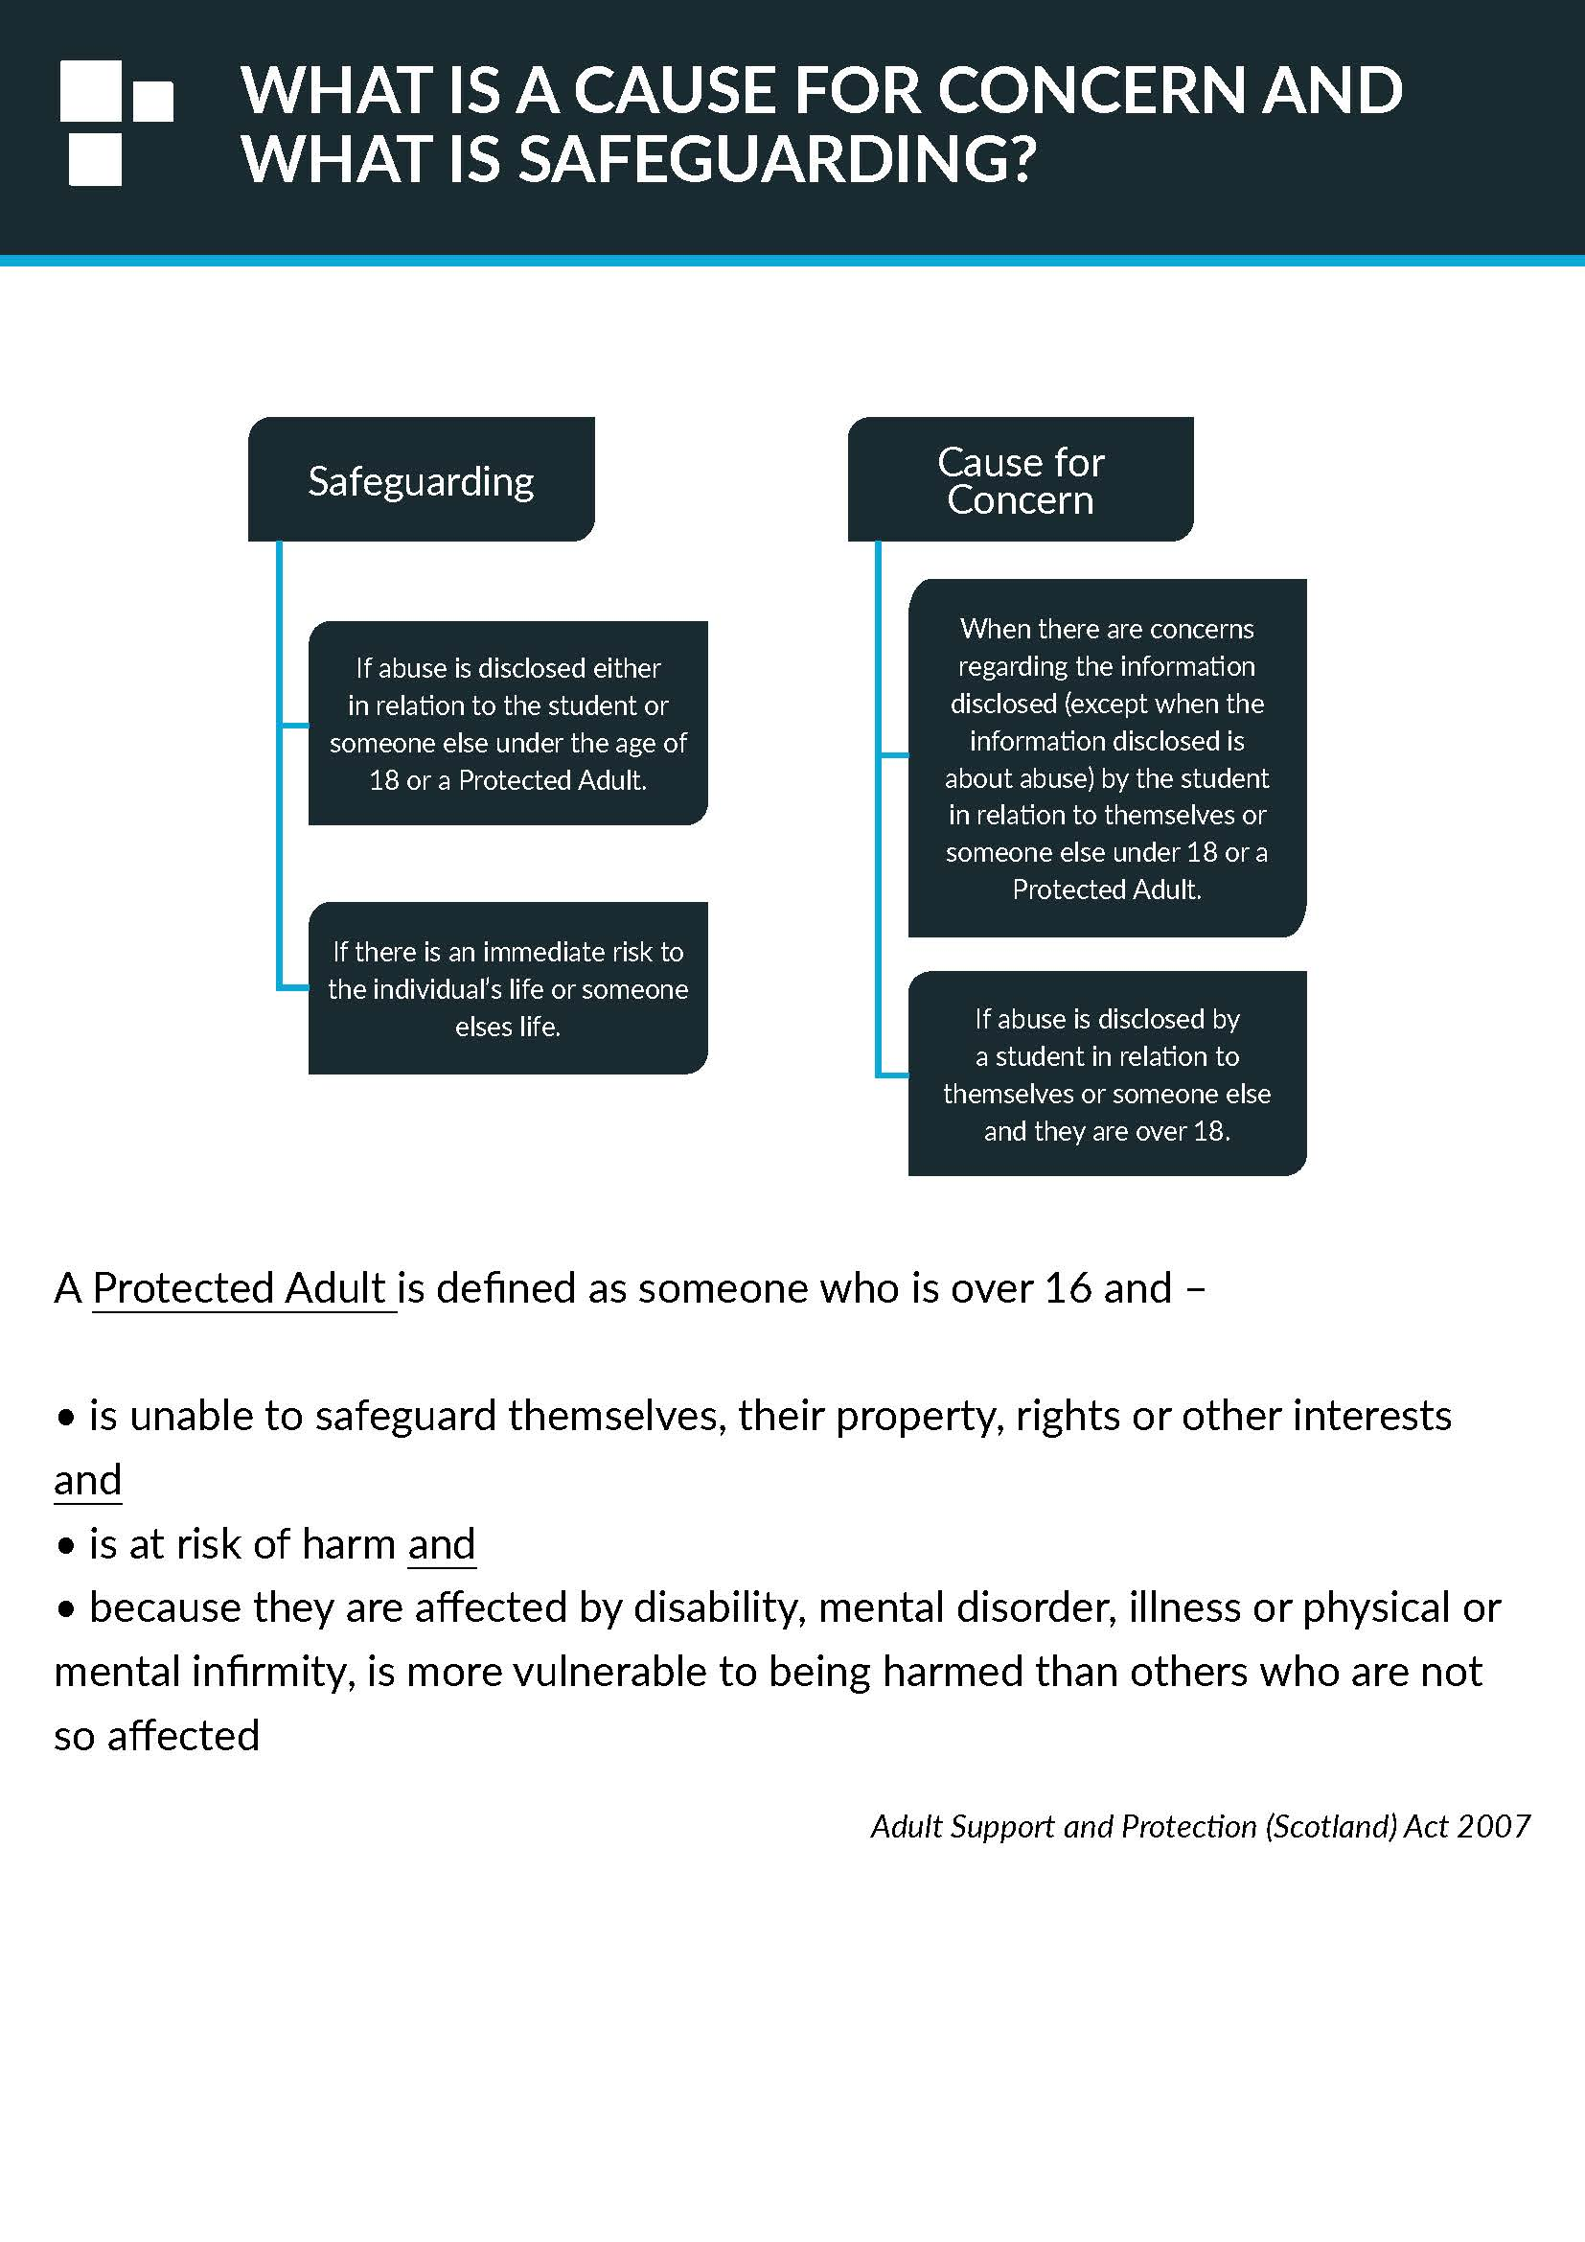

15. Appendix 3 – Safeguarding flowchart
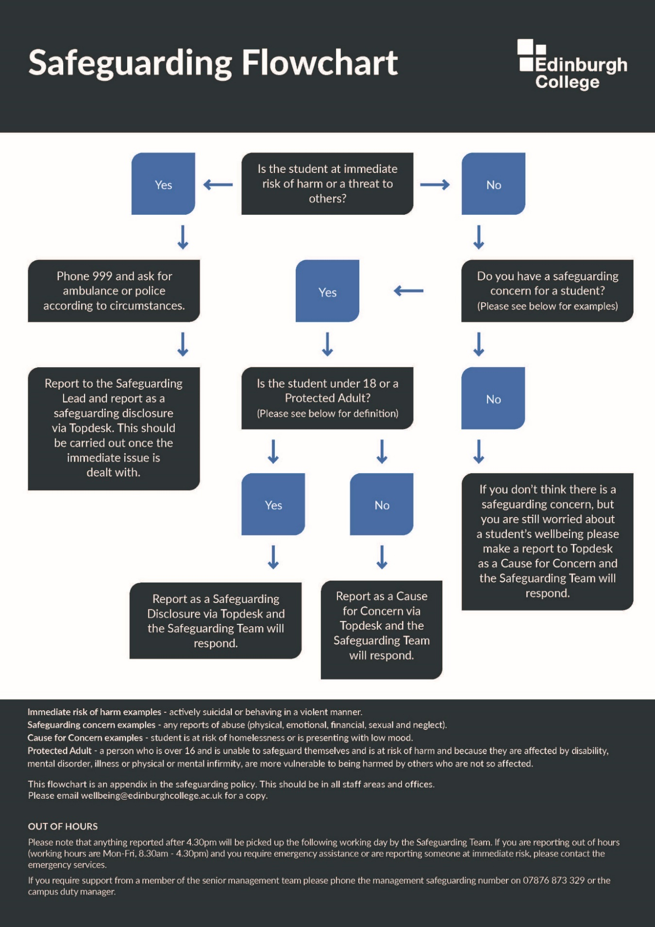


16. Appendix 4 – Template letter

Dear students name,

I am writing in reference to your current place on the course name at campus name.

After careful consideration by the Edinburgh College it has been decided that this academic year 2023/24 isn’t the right time for you to attend college. We feel that you need time to focus on – give details.

This decision will be reviewed in the next academic year state what one so please take this time to work with list support services. At this review we will be looking for evidence that demonstrates that you are able to successfully study at Edinburgh College without putting yourself or others at risk/with the correct support and methods to help you sustain your studies.

Please note this decision cannot be appealed. For further details please refer to the Safeguarding Policy attached.

If you would like any further information please let me know.

Yours Sincerely,

CM/CL NAME

Job title

Firstname.surname@edinburghcollege.ac.uk
Tel:

Enclosed: Edinburgh College Safeguarding Policy

End of document

